Rural Development Programme 2014 – 2022 (LEADER)

Expression of Interest (EOI) Form

NOTE: This Expression of Interest (EOI) form must be completed as a pre-cursor to an application proper for funding under the Rural Development Programme (RDP) 2014 – 2022 (LEADER).
Failure to complete this form completely will result in a delay in dealing with your Expression of Interest and any further processing of any subsequent application arising therefrom.

Completion Guidance Notes:
- Please complete this form in full. All fields are mandatory.
This form can be downloaded or printed from the following website www.stdc.ie and emailed/posted to your Local Action Group with any additional information you feel may be of relevance to your Expression of Interest.
- It can also be completed electronically and e-mailed to your Local Action Group.
- A hardcopy of this form can be obtained from your Local Action Group.
- A Rural Development Officer from the Local Action Group will contact you when your Expression of Interest Form has been reviewed.
- If you require assistance in completing this form, please contact your Local Action Group at: Contact details
South Tipperary Development CLG
Unit 2C, Carrigeen Commercial Park, Clogheen Road,, Cahir, Co. Tipperary
052 7442652
info@stdc.ie

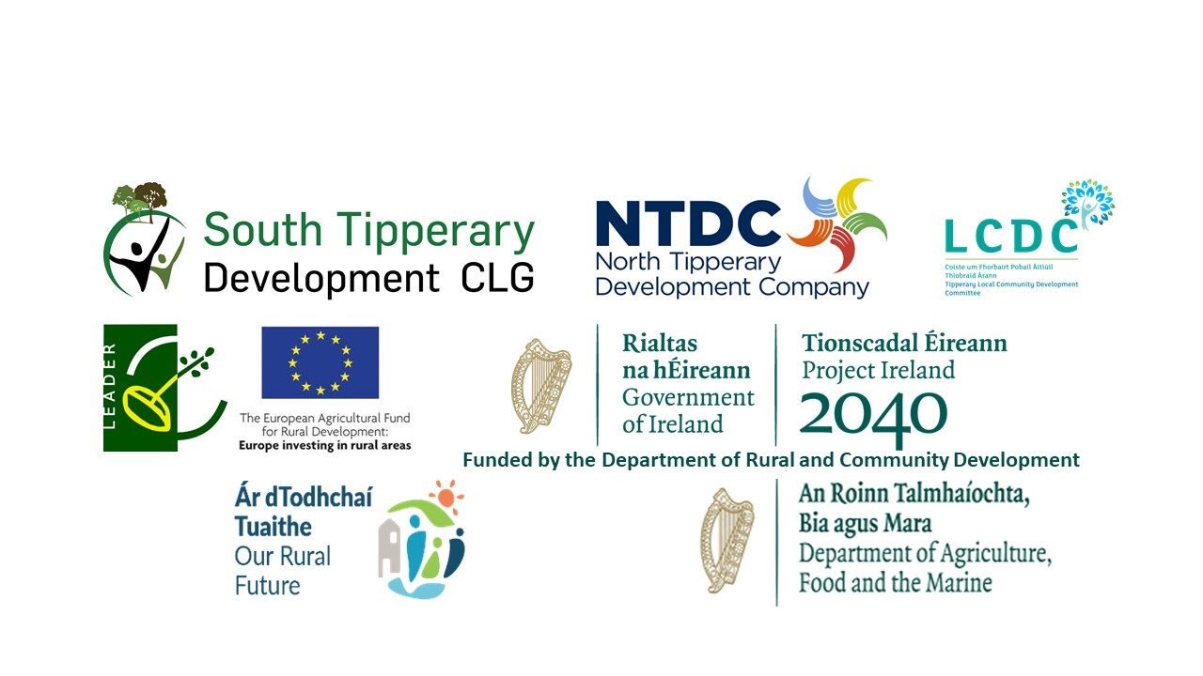

Rural Development Programme (LEADER) 2014 – 2022
Expression of Interest (EOI) Form
GENERAL INFORMATION
All fields are mandatory and must be completed.
Your Local Action Group (LAG) name: | South Tipperary Development Company CLG
Project Name / Title:

Promoter’s / Community Group’s Name:

Promoter’s Lead / Main Contact Name:

Promoter’s Main Telephone No.:
Promoter’s E-mail Address:
Promoter’s Address:
Promoter Type:  [Individual, Community Group, Organisation, Other]. | Classification of Promoter:  Cross appropriate box  Sole Trader Community Council  Farmer(If Yes Herd No. is required below) Trust  Formalised Community/Voluntary group Partnership  Companies Limited by Guarantee Company  Limited by shares  Designated Activity Company limited Public Body  by shares  Registered Charity Private Individual  Cooperative society registered under the Industrial & Provident  Societies Act  Other _________________  Note: Public Bodies are not eligible for LEADER or EURI funding.

Has Promoter / Community Group received LEADER funding previously?  Please tick one | YES  NO
PROJECT INFORMATION
Project Address:

Eircode (Mandatory)
Project located in Gaeltacht area : |  | YES  NO
Project located on Islands area : |  | YES  NO
Estimated Project Costs:
[Total estimated costs]
LEADER Funding Required for project:
Project’s Other Funding sources
(If Any - Bank Loans etc.)
Herd Number:
Please give a brief description of the proposed project.
i.e. what you want the grant for and why
[Please use additional sheet and attach to this form if required.]

Signed for and on behalf of the Promoter / Group:
I/ We confirm that the details supplied are true and correct to the best of my/our knowledge

Print Name: ________________________________

Signature: ____________________________________

Name in Block Capitals: _________________________

Date: __________/__________________/_________

Part or all of the information you provide will be held on computer and hard copy format. This information will be used for the administration of Expression of Interests and producing monitoring returns. LAG’s may share information with each other and government departments/agencies to enable them to prevent fraudulent applications or for detecting crime and to co-ordinate processing of complementary applications.

This policy does not affect your rights and your information will be held as prescribed under the Data Protection Acts.

The promoter/group, the DRCD, South Tipperary Development Company CLG, Tipperary LCDC are subject to the data protection and privacy laws of Ireland and the EU, in particular the Data Protection Act 2018 and Regulation (EU) 2016/679, known as the EU General Data Protection Regulation (“GDPR”). Any personal information that you provide as part of the application process will be obtained and processed in compliance with Data Protection legislation.

This EOI may also be subject to meeting obligations under the Freedom of Information Act 2014. The DRCD, South Tipperary Development Company CLG, Tipperary LCDC retain the right to disclose for the purposes of a request under the Freedom of Information Act 2014 or otherwise, in connection with this EOI.
i. any information supplied by the promoter/group to the DRCD, South Tipperary Development Company CLG, Tipperary LCDC;
ii. any relevant data gathered by the DRCD, South Tipperary Development Company CLG, Tipperary LCDC in processing this EOI, except where the information is considered to be personal or commercially sensitive.

EOI Ref ID: _____________________________ (Generated from RDP IT System)
Call Type: (Rolling / Time Limited) ________________________________.
Main Programme Theme: _____________________________________________________________
________________________________________________________________________________
LAG Officer Signature: __________________________________
Printed name of LAG Officer:______________________________________
Date form Received from Promoter in LAG:____________/__________________/________
LAG Date Stamp:

